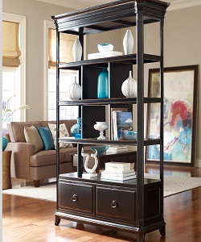

Simple Wooden Divider

$131.30

Availability: In stock

**Decription:**

Simple wooden brown divider with 10 sections and 2 drawers. this room divider can be used to define space in an open concept room, or can be set in front of a large window for privacy. Rounding out the design, metal hinges make folding and storage a breeze when not in use.